Exp 2 : Network Topology Creation using Scilab

Name: Harshit Bisht
Registration Number: 24BCE5008

A .Display the created topology
B. Number the nodes and edges
C. Colour the nodes and edges.

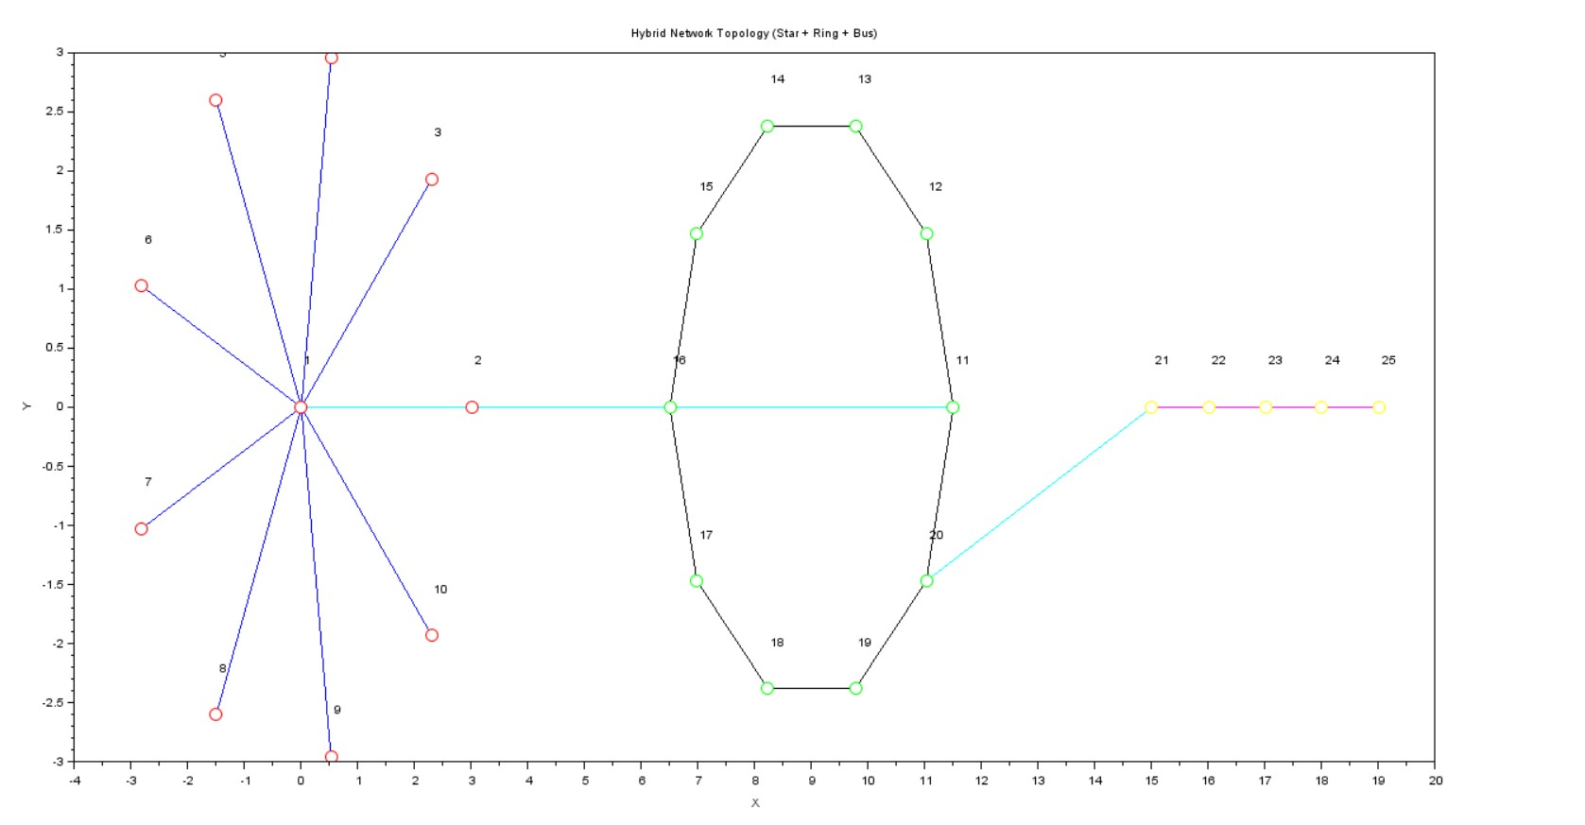

D. Print the number of edges every node has along with the node with maximum edges
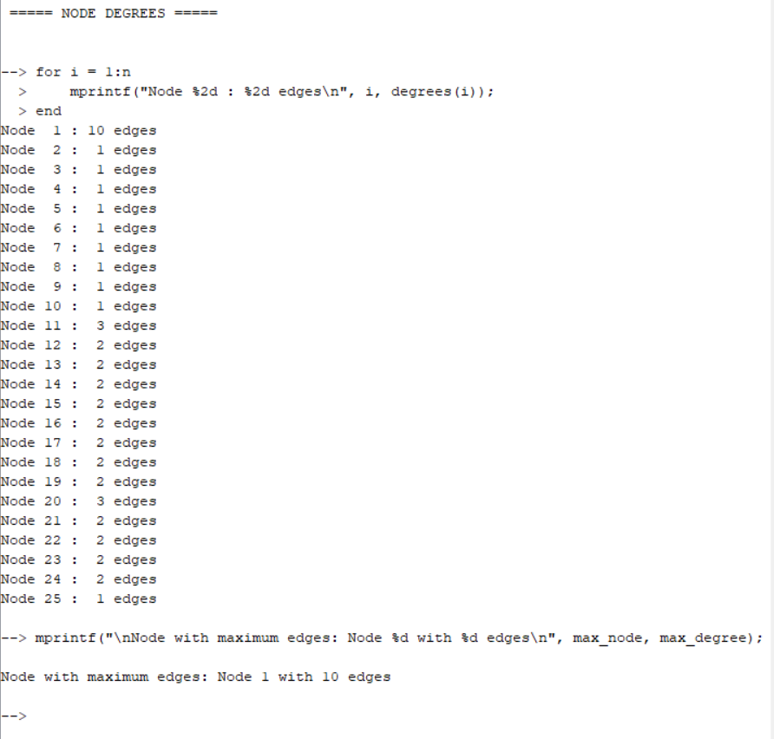

E. Print the total number of nodes and edges
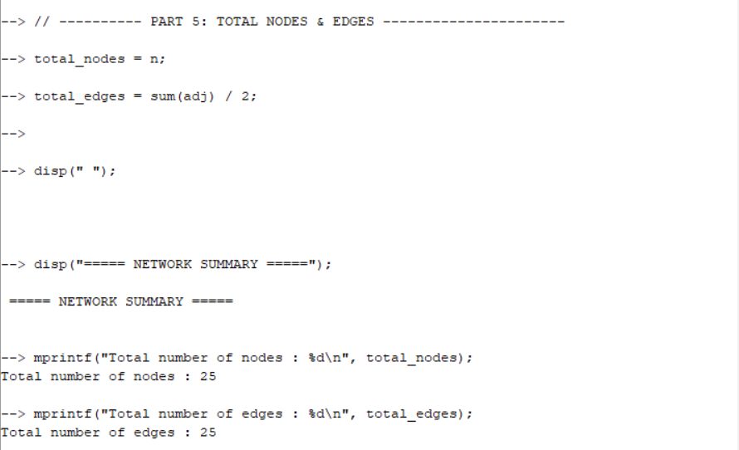

Code
clear
clc

adj = zeros(25, 25);

for i = 2:10
adj(1, i) = 1;
adj(i, 1) = 1;
end

for i = 11:19
adj(i, i+1) = 1;
adj(i+1, i) = 1;
end
adj(20, 11) = 1;
adj(11, 20) = 1;

for i = 21:24
adj(i, i+1) = 1;
adj(i+1, i) = 1;
end

adj(1, 11) = 1; adj(11, 1) = 1;
adj(20, 21) = 1; adj(21, 20) = 1;

n = 25;
x = [];
y = [];

for i = 1:10
if i == 1 then
x = [x, 0];
y = [y, 0];
else
angle = (i-2) * 2 * %pi / 9;
x = [x, 3 * cos(angle)];
y = [y, 3 * sin(angle)];
end
end

for i = 11:20
angle = (i-11) * 2 * %pi / 10;
x = [x, 9 + 2.5 * cos(angle)];
y = [y, 2.5 * sin(angle)];
end

for i = 21:25
x = [x, 15 + (i-21)];
y = [y, 0];
end

scf(1);
clf();

for i = 2:10
if adj(1, i) == 1 then
plot([x(1) x(i)], [y(1) y(i)], 'b-', 'thickness', 1);
end
end

for i = 11:19
if adj(i, i+1) == 1 then
plot([x(i) x(i+1)], [y(i) y(i+1)], 'k-', 'thickness', 1);
end
end
if adj(20, 11) == 1 then
plot([x(20) x(11)], [y(20) y(11)], 'k-', 'thickness', 1);
end

for i = 21:24
if adj(i, i+1) == 1 then
plot([x(i) x(i+1)], [y(i) y(i+1)], 'm-', 'thickness', 1);
end
end

if adj(1, 11) == 1 then
plot([x(1) x(11)], [y(1) y(11)], 'c-', 'thickness', 1);
end
if adj(20, 21) == 1 then
plot([x(20) x(21)], [y(20) y(21)], 'c-', 'thickness', 1);
end

for i = 1:10
plot(x(i), y(i), 'ro', 'marksize', 10);
end
for i = 11:20
plot(x(i), y(i), 'go', 'marksize', 10);
end
for i = 21:25
plot(x(i), y(i), 'yo', 'marksize', 10);
end

for i = 1:n
xstring(x(i), y(i) + 0.3, string(i));
end

title("Hybrid Network Topology (Star + Ring + Bus)");
xlabel("X");
ylabel("Y");
axis("equal");
grid("on");

degrees = sum(adj, 2);
[max_degree, max_node] = max(degrees);

disp("===== NODE DEGREES =====");
for i = 1:n
mprintf("Node %2d : %2d edges\n", i, degrees(i));
end
mprintf("\nNode with maximum edges: Node %d with %d edges\n", max_node, max_degree);

total_nodes = n;
total_edges = sum(adj) / 2;

disp(" ");
disp("===== NETWORK SUMMARY =====");
mprintf("Total number of nodes : %d\n", total_nodes);
mprintf("Total number of edges : %d\n", total_edges);

Scenario-based question
A company uses the following hybrid network for its internal communication:
- Department A (Customer Support) is connected using a star topology with nodes 1–10, where node 1 is the central server in the support department.
- Department B (Data Processing) is connected using a ring topology with nodes 11–20, where all processing nodes circulate data among themselves.
- Department C (Administration) is connected using a bus topology with nodes 21–25, where administrative systems share a common communication line.
- The three departments are interconnected as follows: node 1 (star hub) is connected to node 11 (entry point of the ring), and node 20 (ring) is connected to node 21 (first bus node).
Question:
- If node 1 (the central server of Department A) fails,
  - Which department(s) lose connectivity completely?
Department A (star, nodes 1–10) loses connectivity to its central node; nodes 2–10 cannot communicate with each other through node 1 and are effectively isolated.
  - Which nodes remain connected within their own department?
Departments B and C (ring 11–20 and bus 21–25) remain fully connected internally because their local links are unchanged.
  - Which inter-department paths become unavailable?
All paths that require node 1 are broken, so Department A cannot communicate with Departments B or C, but B and C can still communicate with each other through nodes 20 and 21.
- If the link between nodes 20 and 21 fails but all nodes remain active,
  - Describe how this affects communication between the ring and bus topologies.
The ring (nodes 11–20) and bus (nodes 21–25) can no longer exchange data, because their only interconnection (edge 20–21) is down.
  - State whether internal communication within each department is still possible.
Internal communication inside each department remains possible: the star, ring, and bus structures are intact, so each department’s nodes can still communicate within their own topology.

GitHub Repo Link

